Help for non-English speakers
If you need help to understand the information in this policy, please contact Hume Valley School.
Ph: 9309 3477
Purpose
The purpose of this policy is to outline the procedures our school has in place to respond to complaints or concerns relating to child abuse and to ensure that all staff and members of our school community understand and follow the various legal obligations that apply to the reporting of child abuse to relevant authorities.
Scope
This policy applies to complaints and concerns relating to child abuse made by or in relation to a child or student, school staff, volunteers, contractors, service providers, visitors or any other person while connected to the school (physical and online).
Definitions
Child abuse
Child abuse includes:
- physical violence inflicted on a child
- sexual offences committed against a child
- grooming of a child by an adult
- family violence committed against or in the presence of a child
- serious emotional or psychological harm to a child
- serious neglect of a child.
The definition of child abuse is broad and can include student to student incidents and concerns, as well as behaviour committed by an adult.
Grooming
Grooming is a criminal offence under the Crimes Act 1958 (Vic) and is a form of child abuse and sexual misconduct. This offence targets predatory conduct undertaken by an adult to prepare a child under the age of 16 to engage in sexual activity at a later time, either with the groomer or with another adult. Grooming can include communicating (including electronic communications and communicating by conduct) and/or attempting to befriend or establish a relationship or other emotional connection with the child or their parent or carer.
School staff member
For the purpose of this policy a school staff member includes a contractor engaged by the school or school council to perform child-related work.

Policy
Hume Valley School understands the important role our school plays in protecting children from abuse. We have a range of policies and measures in place to prevent child abuse from occurring at our school or during school activities.
Information for students
- All students should feel safe to speak to any staff member to raise any concerns about their safety or any other concerns that they have.
- If a student does not know who to approach at Hume Valley School they should start with All students should feel safe to speak to any staff member to raise any concerns about their safety or any other concerns that they have.

Hume Valley School has nominated a child safety champion (Student Wellbeing Leading Teacher) to support the principal to implement our child safety policies and practices, including staff and volunteer training.
The responsibilities of the child safety champion are outlined at Guidance for child safety champions
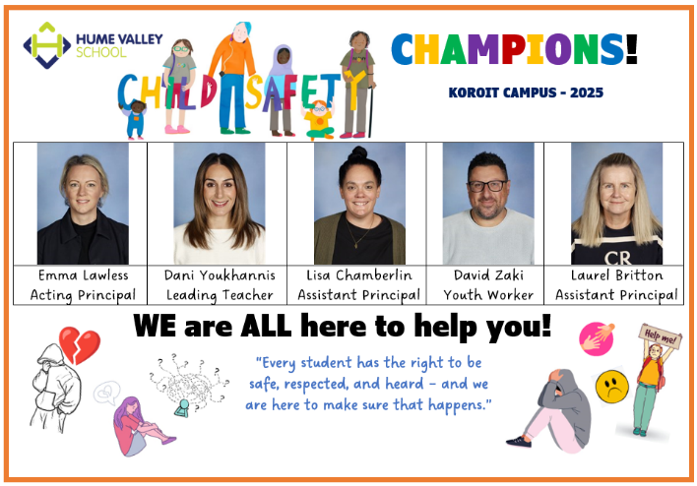
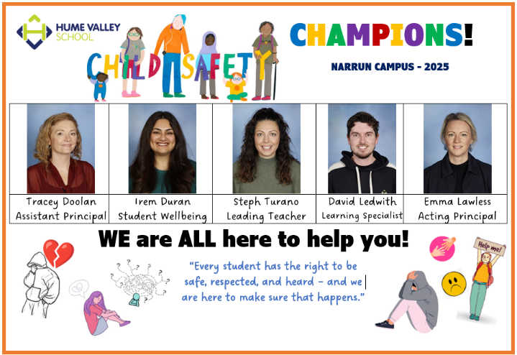

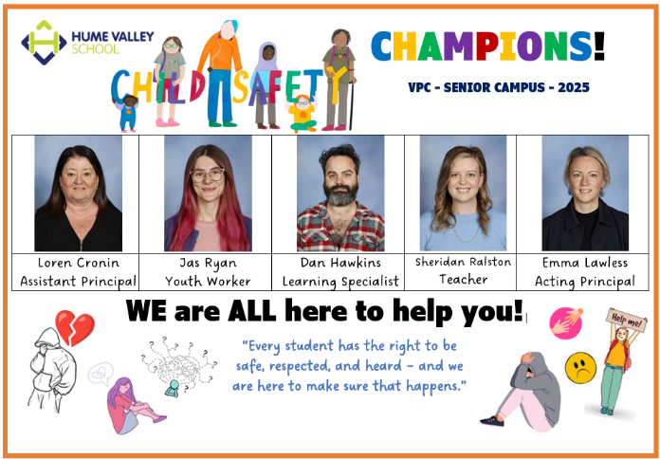

Identifying child abuse
To ensure we can respond in the best interests of students and children when complaints or concerns relating to child abuse are raised, all staff and relevant volunteers must:
- understand how to identify signs of child abuse and behavioural indicators of perpetrators - for detailed information on identifying child abuse and behavioural indicators of perpetrators refer to Identify child abuse.
- understand their various legal obligations in relation to reporting child abuse to relevant authorities - for detailed information on the various legal obligations refer to Appendix A
- follow the below procedures for responding to complaints or concerns relating to child abuse, which ensure our school acts in the best interests of students and children and complies with both our legal and Department policy obligations.
At Hume Valley School we recognise the diversity of the children, young people, and families at our school and take account of their individual needs and backgrounds when considering and responding to child safety incidents or concerns.
Procedures for responding to an incident, disclosure, allegation or suspicion of child abuse
In responding to a child safety incident, disclosure, allegation or suspicion, Hume Valley School will follow:
- the Four Critical Actions for Schools for complaints and concerns relating to all forms of child abuse
- the Four Critical Actions: Student Sexual Offending for complaints and concerns relating to student sexual offending
- our Student Wellbeing and Engagement Policy and Bullying Prevention Policy for complaints and concerns relating to student physical violence or other harmful student behaviours.
School staff and volunteer responsibilities
- Immediate action
If a school staff member or volunteer witnesses an incident of child abuse, or reasonably believes, suspects or receives a disclosure or allegation that a child has been, or is at risk of being abused, they must:
- If a child is at immediate risk of harm, separate alleged victims and others involved, administer first aid (appropriate to their level of training) and call 000 for urgent medical or police assistance where required to respond to immediate health or safety concerns.
- Notify the principal, child safe champions or a member of the leadership team (comprising the principal, assistant principals and acting assistant principals, leading teachers and learning specialists) or wellbeing team as soon as possible, who will ensure our school follows the steps in these procedures.
NOTE for staff and volunteers:
- if you are uncertain if an incident, disclosure, allegation or suspicion gives rise to a concern about child abuse you must always err on the side of caution and report the concern to leadership or a member of the wellbeing team.
- If the concerns relates to the conduct of staff members referred to above, notify the department by phone on 1800 338 663, via the Enquiries form or by email at enquiries@education.vic.gov.au] who must then take on responsibility for ensuring our school follows these procedures.
Refer to Appendix B for guidance on how to respond to a disclosure of child abuse.
- Reporting to authorities and referring to services
As soon as immediate health and safety concerns are addressed, and relevant school staff have been informed, the leadership or wellbeing team member must report all incidents, suspicions and disclosures of child abuse as soon as possible.
The following steps will ensure our school complies with the four critical actions as well as additional actions required under the Child Safe Standards.
The leadership or wellbeing team member must ensure:
- all relevant information is reported to the Department of Families, Fairness and Housing (DFFH) Child Protection, Victoria Police or relevant services where required
- the incident is reported to the Department’s eduSafe Plus portal or the Incident Support and Operations Centre (1800 126 126) in accordance with the severity rating outlined in the Managing and Reporting School Incidents Policy
- all reportable conduct allegations or incidents are reported by the Principal to the Department’s Employee Conduct Branch (03 7022 0005) – where a reportable conduct allegation is made against the Principal, the Regional Director must be informed who will then make a report to Employee Conduct Branch
NOTE: In circumstances where staff members are legally required to report child abuse to DFFH Child Protection or Victoria Police and they are unable to confirm that the information has been reported by another person at the school or the designated member of school staff does not agree that a report needs to be made, the staff member who has formed the reasonable belief must still contact DFFH Child Protection and Victoria Police to make the report.
If you believe that a child is not subject to abuse, but you still hold significant concerns for their wellbeing you must still act. This may include making a referral or seeking advice from Child FIRST or The Orange Door (in circumstances where the family are open to receiving support) DFFH Child Protection or Victoria Police.
- Contacting parents or carers
The member of leadership or wellbeing team must ensure parents and carers are notified unless advised otherwise by DFFH Child Protection or Victoria Police, or there are other safety and wellbeing concerns in relation to informing parents/carers.
Principals may contact the Department of Education Legal Division for advice on notifying parents and carers, and where relevant, the wider school community.
For further guidance, refer to PROTECT Contacting parents and carers
- Ongoing protection and support
The member of leadership or wellbeing team ensure appropriate steps are taken by the school to protect the child and other children from any continued risk of abuse. These steps must be taken in consultation with any relevant external agency or Department staff such as DFFH Child Protection, Victoria Police, Legal Division or Employee Conduct Branch. Ongoing protection will also include further reports to authorities if new information comes to light or further incidents occur.
Appropriate, culturally sensitive and ongoing support must be offered and provided to all affected students. Ongoing support will be based on any available advice from the Department, parents and carers, health practitioners, and other authorities (such as DFFH or Victoria Police) and may include referral to wellbeing professionals, development of a safety plan, student support group meetings, and, for student to student incidents, behaviour management and support measures.
- Recordkeeping
The leadership and Wellbeing Team will ensure that:
- detailed notes of the incident, disclosure, allegation or suspicion are taken including, where possible, by the staff member or volunteer who reported the incident, disclosure, or suspicion to them
- detailed notes are taken of any immediate or ongoing action taken by the school to respond to the incident, disclosure, allegation or suspicion
- We acknowledge that good records management practices are a critical element of child safety and wellbeing and manage our records in accordance with the Department of Education’s policy: Records Management – School Records
For school visitors and school community members
All community members aged 18 years or over have legal obligations relating to reporting child abuse – refer to Appendix A for detailed information.
Any person can make a report to DFFH Child Protection or Victoria Police if they believe on reasonable grounds that a child is in need of protection. For contact details, refer to the Four Critical Actions.
Members of the community do not have to inform the school if they are making a disclosure to DFFH Child Protection or the Victoria Police. However, where a community member is concerned about the safety of a child or children at the school, the community member should report this concern to the principal so that appropriate steps to support the student can be taken
Additional requirements for all staff
All staff play an important role in supporting student safety and wellbeing and have a duty of care to take reasonable steps to prevent reasonably foreseeable harm to students.
Fulfilling the roles and responsibilities in the above procedure does not displace or discharge any other obligations that arise if a person reasonably believes that a child is at risk of child abuse. This means that if, after following the actions outlined in the procedure, a staff member reasonably believes that a child remains at risk of abuse, they must take the following steps:
- if they are concerned that the school has not taken reasonable steps to prevent or reduce the risk, raise these concerns with the principal in the first instance, and escalate to the regional office if they remain unsatisfied.
- report the matter to the relevant authorities where they are unable to confirm that the information has been reported by another staff member
Staff must refer to Appendix A for further information on their obligations relating to reporting to authorities.
COMMUNICATION
This policy will be communicated to our school community in the following ways:
- Available publicly on our school’s website (or insert other online parent, carer, student communication method)
- Included in staff induction processes and annual staff training
- Included in volunteer induction processes and training for relevant volunteers
- Discussed an annual staff briefings or meetings
- Included in staff handbook or manual
- Hard copy available from school administration upon request

Further information and RESOURCES
The following Department of Education policies and guidance are relevant to this policy:
- Child Safe Standards
- Protecting Children — Reporting and Other Legal Obligations
- Managing and Reporting School Incidents
- Reportable Conduct
- Restraint and Seclusion
- Identify child abuse
- Report child abuse in schools (including four critical actions)
- Identify and respond to student sexual offending
The following school policies are also relevant to this policy:
- Child Safety [and Wellbeing] Policy
- Child Safety Code of Conduct
- Statement of Values and School Philosophy
- Student Wellbeing and Engagement Policy
- Volunteer Policy
- Duty of Care Policy
- Inclusion and Diversity Policy
POLICY REVIEW AND APPROVAL
Policy last reviewed | February 2026
Consultation | Student Wellbeing Team, PCT
Approved by | Principal
Next scheduled review date | February 2028

APPENDIX A
legal obligatIons relating to reporting child abuse
The following information outlines the various legal obligations relating to the reporting of child abuse to relevant authorities.
It is important to note that the procedures outlined in the above policy ensure compliance with the below reporting obligations, and also include additional steps to ensure compliance with Department policy and our school’s duty of care obligations.
Mandatory reporting to Department of Families, Fairness and Housing (DFFH) Child Protection
The following individuals are mandatory reporters under the Children, Youth and Families Act 2005 (Vic):
- registered teachers and early childhood teachers (including principals and school staff who have been granted permission to teach by the VIT)
- school counsellors including staff who provide direct support to students for mental, emotional or psychological wellbeing, including (but not limited to) school health and wellbeing staff, primary welfare coordinators, student wellbeing coordinators, mental health practitioners, chaplains, and Student Support Services staff
- nurses
- registered psychologists
- police officers
- registered medical practitioners
- out of home care workers (excluding voluntary foster and kinship carers)
- early childhood workers
- youth justice workers
- people in religious ministry
- midwives
All mandatory reporters must make a report to the Department of Families, Fairness and Housing (DFFH) Child Protection as soon as practicable if, during the course of carrying out their professional roles and responsibilities, they form a belief on reasonable grounds that:
- a child has suffered, or is likely to suffer, significant harm as a result of physical abuse and/ or sexual abuse; and
- the child’s parents or carers have not protected, or are unlikely to protect, the child from harm of that type.
A mandatory reporter who fails to comply with this legal obligation may be committing a criminal offence. It is important for all staff at Hume Valley School to be aware that they are legally obliged to make a mandatory report on each occasion that they form a reasonable belief that a child is in need of protection and they must make a mandatory report even if the principal or any other mandatory reporter does not share their belief that a report is necessary.
If charged with not making a mandatory report, it may be a defence for the person charged to prove that they honestly and reasonably believed that all of the reasonable grounds for their belief had been the subject of a report to child protection made by another person.
The identity of a person who reports any protective concerns to DFFH Child Protection is protected by law. It is an offence for a person, other than the person who made the report, to disclose the name of the person who made a report or any information that is likely to lead to their identification.
At our school, all mandated school staff must undertake the Mandatory Reporting and Other Obligations eLearning Module annually.
The policy of the Department of Education requires all staff who form a reasonable belief that a child is in need of protection to discuss their concerns with the school leadership team and to report their concerns to DFFH and in some circumstances to Victoria Police, or to ensure that all the information relevant to the report has been made by another school staff member.
Any person can make a report to DFFH Child Protection (131 278 – 24 hour service) if they believe on reasonable grounds that a child is in need of protection even if they are not a mandatory reporter listed above.

Reporting student wellbeing concerns to Child FIRST/Orange Door

At Hume Valley School we also encourage staff to make a referral to Child FIRST/Orange Door when they have significant concern for a child’s wellbeing. For more information about making a referral to Child FIRST/Orange Door see the Policy and Advisory Library: Protecting Children – Reporting and Other Legal Obligations.

Reportable Conduct
The Reportable Conduct Scheme is focussed on worker and volunteer conduct and how organisations investigate and respond to suspected child abuse. The scheme aims to improve organisational responses to suspected child abuse and to facilitate the identification of individuals who pose a risk of harm to children.
There are five types of ‘reportable conduct’ listed in the Child Wellbeing and Safety Act 2005:
- sexual offences against, with or in the presence of, a child
- sexual misconduct (which includes grooming) against, with or in the presence of, a child
- physical violence against, with or in the presence of, a child
- behaviour that causes significant emotional or psychological harm to a child
- significant neglect of a child.
A reportable conduct allegation is made where a person makes an allegation, based on a reasonable belief, that a worker or volunteer has committed reportable conduct or misconduct that may involve reportable conduct.
If school staff or volunteers become aware of reportable conduct by any current or former employee, contractor or volunteer, they must notify the school principal immediately. If the allegation relates to the principal, they must notify the Regional Director.
The principal or regional director must notify the Department’s Employee Conduct Branch of any reportable conduct allegations involving current or former employees of the school (including Department, allied health, casual and school council employees), contractors and volunteers (including parent volunteers).
- Employee Conduct Branch: 03 7022 0005 or employee.conduct@education.vic.gov.au
The Department’s Secretary, through the Manager, Employee Conduct Branch, has a legal obligation to inform the Commission for Children and Young People when an allegation of reportable conduct is made.
For more information about reportable conduct see the Department’s Policy and Advisory Library: Reportable Conduct and the Commission for Children and Young People’s website.

Failure to disclose offence
Reporting child sexual abuse is a community-wide responsibility. All adults (ie persons aged 18 years and over), not just professionals who work with children, have a legal obligation to report to Victoria Police, as soon as practicable, where they form a ‘reasonable belief’ that a sexual offence has been committed by an adult against a child under the age of 16 in Victoria.
Failure to disclose information to Victoria Police (by calling 000, local police station or the Police Assistance Line 131 444) as soon as practicable may amount to a criminal offence unless a person has a ‘reasonable excuse’ or exemption from doing so.
“Reasonable belief” is not the same as having proof. A ‘reasonable belief’ is formed if a reasonable person in the same position would have formed the belief on the same grounds.
For example, a ‘reasonable belief’ might be formed when:
- a child states that they have been sexually abused
- a child states that they know someone who has been sexually abused (sometimes the child may be talking about themselves)
- someone who knows a child states that the child has been sexually abused
- professional observations of the child’s behaviour or development leads a mandated professional to form a belief that the child has been sexually abused
- signs of sexual abuse leads to a belief that the child has been sexually abused.
“Reasonable excuse” is defined by law and includes:
- fear for the safety of any person including yourself or the potential victim (but not including the alleged perpetrator or an organisation)
- where the information has already been disclosed to Victoria Police and you have no further information to add (for example, through a mandatory report to DFFH Child Protection or a report to Victoria Police from another member of school staff).

Failure to protect offence
This reporting obligation applies to school staff in a position of authority. This can include principals, assistant principals and campus principals. Any staff member in a position of authority who becomes aware that an adult associated with their school (such as an employee, contractor, volunteer or visitor) poses a risk of sexual abuse to a child under the age of 16 under their care, authority or supervision, must take all reasonable steps to remove or reduce that risk.
This may include removing the adult (ie persons aged 18 years and over) from working with children pending an investigation and reporting your concerns to Victoria Police.
If a school staff member in a position of authority fails to take reasonable steps in these circumstances, this may amount to a criminal offence.
Further information
For more information about the offences and reporting obligations outlined in this fact sheet refer to: Protecting Children — Reporting and Other Legal Obligations.

APPENDIX B: managing disclosures of child abuse
Important information for staff
When managing a disclosure relating to child abuse you should:
- listen to the student and allow them to speak
- stay calm and use a neutral tone with no urgency and where possible use the child’s language and vocabulary (you do not want to frighten the child or interrupt the child)
- be gentle, patient and non-judgmental throughout
- highlight to the student it was important for them to tell you about what has happened
- assure them that they are not to blame for what has occurred
- do not ask leading questions, for example gently ask, “What happened next?” rather than “Why?”
- be patient and allow the child to talk at their own pace and in their own words
- do not pressure the child into telling you more than they want to, they will be asked a lot of questions by other professionals, and it is important not to force them to retell what has occurred multiple times
- reassure the child that you believe them and that disclosing the matter was important for them to do
- use verbal facilitators such as, “I see”, restate the child’s previous statement, and use non-suggestive words of encouragement, designed to keep the child talking in an open-ended way (“what happened next?”)
- tell the child in age appropriate language you are required to report to the relevant authority to help stop the abuse, and explain the role of these authorities if appropriate (for a young child this may be as simple as saying “I will need to talk to people to work out what to do next to help you”)
- Take prompt action in relation to following the procedures outlined below.
When managing a disclosure you should AVOID:
- displaying expressions of panic or shock
- asking questions that are investigative and potentially invasive (this may make the child feel uncomfortable and may cause the child to withdraw)
- going over the information repeatedly (you are only gathering information to help you form a belief on reasonable grounds that you need to make a report to the relevant authority)
- making any comments that would lead the student to believe that what has happened is their fault
- making any promises you will keep the information the student provided confidential
- making promises to the child about what will occur next or that things will be different given the process can be unpredictable and different for each child depending on their circumstances (instead reassure them that you and others will do your best to help).

