 | Help for non-English speakers  If you need help to understand the information in this policy please contact Hume Valley School.  Ph: 9309 3477

Purpose

The Hume Valley School Child Safety and Wellbeing Policy demonstrates our school’s commitment to creating and maintaining a child safe and child-friendly organisation, where children and young people are safe and feel safe.
This policy provides an overview of our school’s approach to implementing Ministerial Order 1359 which sets out how the Victorian Child Safe Standards apply in school environments.
It informs our school community of everyone’s obligations to act safely and appropriately towards children and guides our processes and practices for the safety and wellbeing of students across all areas of our work.

Scope
This policy:
- applies to all school staff, volunteers and contractors whether or not they work in direct contact with students. It also applies to school council members where indicated.
- applies in all physical and online school environments used by students during or outside of school hours, including other locations provided by for a student’s use (for example, a school camp) and those provided through third-party providers
- should be read together with our other child safety and wellbeing policies, procedures, and codes – refer to the related school policies section below.

Definitions
The following terms in this policy have specific definitions:
- child
- child safety
- child abuse
- child-connected work
- child-related work
- school environment
- school boarding environment
- school staff
- school boarding premises staff
- school governing authority
- school boarding premises governing authority
- student
- volunteer.

Statement of commitment to child safety

Hume Valley School is a child safe organisation which welcomes all children, young people and their families.
We are committed to providing environments where our students are safe and feel safe, where their participation is valued, their views respected, and their voices are heard about decisions that affect their lives.

Our child safe policies, strategies and practices are inclusive of the needs of all children and students.
We have no tolerance for child abuse and take proactive steps to identify and manage any risks of harm to students in our school environments.

We promote positive relationships between students and adults and between students and their peers. These relationships are based on trust and respect.

We take proactive steps to identify and manage any risk of harm to students in our school environment. When child safety concerns are raised or identified, we treat these seriously and respond promptly and thoroughly.
Particular attention is given to the child safety needs of Aboriginal students, those from culturally and linguistically diverse backgrounds, international students, students with disabilities, those unable to live at home, children and young people who identify as lesbian, gay, bisexual, trans and gender diverse, intersex, queer, questioning and asexual (LGBTIQA+) and other students experiencing risk or vulnerability.

Inappropriate or harmful behaviour targeting students based on these or other characteristics, such as racism or homophobia, are not tolerated at our school, and any instances identified will be addressed with appropriate consequences.

Child safety is a shared responsibility. Every person involved in our school has an important role in promoting child safety and wellbeing and promptly raising any issues or concerns about a child’s safety.

We are committed to regularly reviewing our child safe practices, and seeking input from our students, families, staff, and volunteers to inform our ongoing strategies.

Roles and responsibilities

School leadership team

Our school leadership team (comprising the principal, assistant principals and acting assistant principals, leading teachers and learning specialists) are responsible for ensuring that a strong child safe culture is created and maintained, and that policies and practices are effectively developed and implemented in accordance with Ministerial Order 1359.

Principals, assistant principals and acting assistant principals, leading teachers and learning specialists will:

- ensure effective child safety and wellbeing governance, policies, procedures, codes and practices are in place and followed
- model a child safe culture that facilitates the active participation of students, families and staff in promoting and improving child safety, cultural safety and wellbeing
- enable inclusive practices where the diverse needs of all students are considered
- reinforce high standards of respectful behaviour between students and adults, and between students
- promote regular open discussion on child safety issues within the school community including at leadership team meetings, staff meetings and school council meetings
- facilitate regular professional learning for staff and volunteers (where appropriate) to build deeper understandings of child safety, cultural safety, student wellbeing and prevention of, and responding to abuse
- create an environment where child safety complaints and concerns are readily raised, and no one is discouraged from reporting an allegation of child abuse to relevant authorities.
School staff and volunteers

All staff and volunteers will:

- participate in child safety and wellbeing induction and training provided by the school or the Department of Education, and always follow the school’s child safety and wellbeing policies and procedures
- act in accordance with our Child Safety Code of Conduct
- identify and raise concerns about child safety issues in accordance with our Child Safety Responding and Reporting Obligations Policy and Procedures, including following the Four Critical Actions for Schools
- ensure students’ views are taken seriously and their voices are heard about decisions that affect their lives
- implement inclusive practices that respond to the diverse needs of students.

School council

In performing the functions and powers given to them under the Education and Training Reform Act 2006, school council members will:

- champion and promote a child safe culture with the broader school community
- ensure that child safety is a regular agenda item at school council meetings to ensure that a culture of child safety is being embedded and school council members are informed and understand the issues
- undertake annual training on child safety - Child Safe Standards School Council Training slide presentation available on PROTECT.
- approve updates to, and act in accordance with the Child Safety Code of Conduct to the extent that it applies to school council employees and members
- when hiring school council employees, ensure that selection, supervision, and management practices are child safe

Specific staff child safety responsibilities

Hume Valley School has nominated a child safety champion (Student Wellbeing Leading Teacher) to support the principal to implement our child safety policies and practices, including staff and volunteer training.
The responsibilities of the child safety champion are outlined at Guidance for child safety champions.

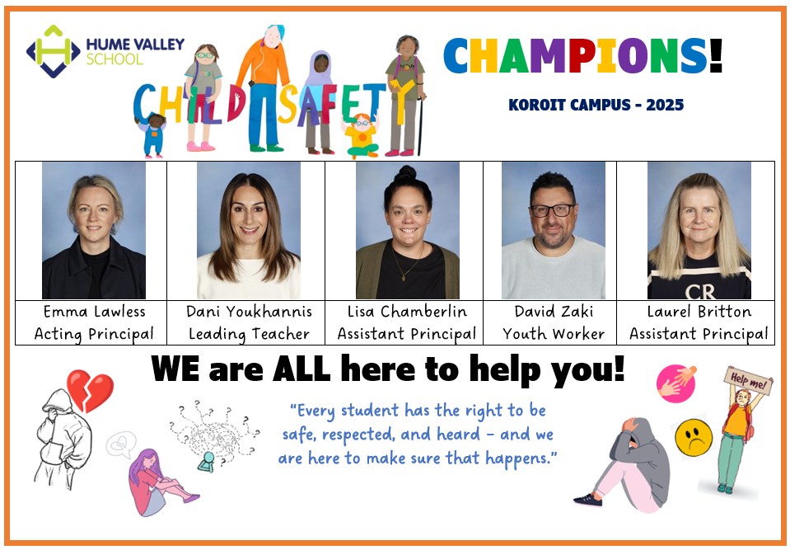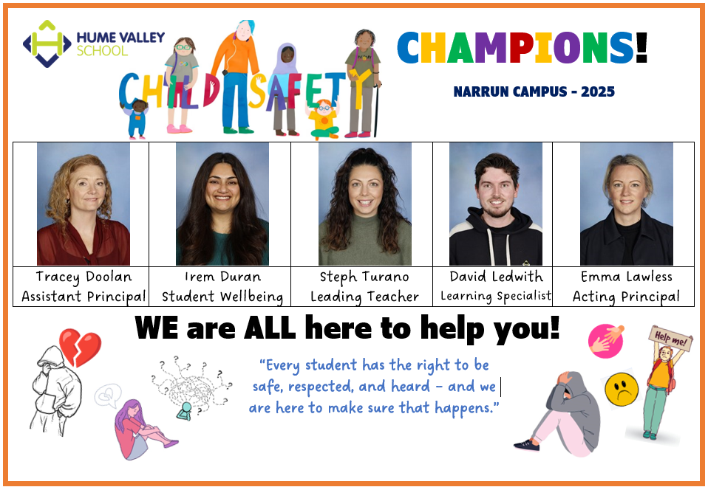

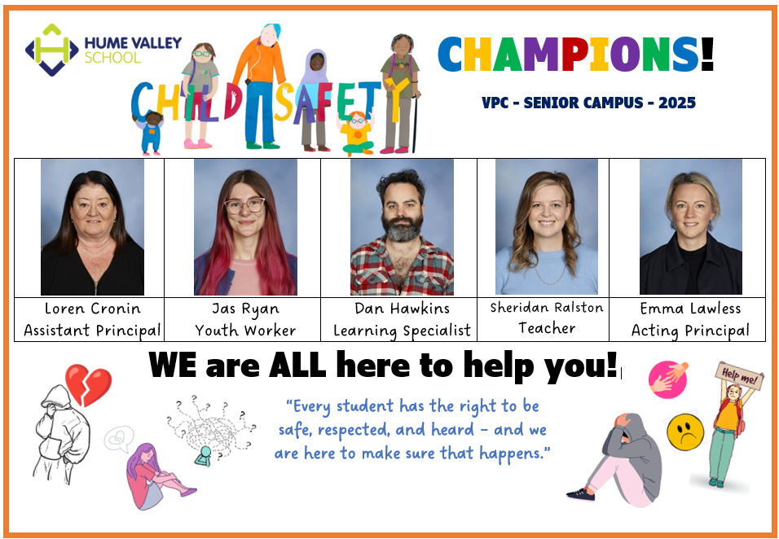

In addition to these roles, our child safety champion is also responsible for:

Promote Child Safety Culture
- Actively promote child safety and wellbeing through staff meetings, newsletters, parent communication, and bulletins.
- Ensure child safety policies and procedures are up-to-date, accessible, understood, and implemented.
- Foster a culture where students and families feel listened to, and where their concerns are acted upon.
- Support staff and volunteers to prioritise the safety needs of vulnerable students.

Provide Support and Guidance
- Serve as the first point of contact for child safety concerns raised by staff, volunteers, or students.
- Provide clear guidance on how to apply child safety policies and procedures in practice.
- Work closely with school leadership to manage and respond to child safety incidents.
- Maintain expertise in key areas including:
  - Complaint processes and reporting obligations (Four Critical Actions).
  - Student rights and participation.
  - Aboriginal cultural safety and inclusive practices.
  - Child safety risk management (including online safety).
  - Information sharing and record-keeping obligations.
- Collaborate with relevant agencies to connect students and families with additional support.
- Stay informed on emerging research and best practice in child safety.

Train and Educate
- Deliver child safety induction for all new staff, volunteers, and school council members.
- Provide ongoing training for staff, volunteers, and council members on child safety responsibilities.
- Ensure mandatory reporters complete the annual mandatory reporting training.
- Share regular updates on child safety obligations, processes, and risks as needed.

Monitor, Review and Report
- Keep accurate and secure records of all child safety concerns, complaints, and referrals.
- Analyse patterns or trends in complaints to identify risks and areas for improvement.
- Coordinate reviews of significant incidents, making recommendations for stronger safeguards.
- Work with leadership to maintain the school’s child safety risk register.

Our principal and child safety champion (Student Wellbeing Leading Teacher) are the first point of contact for child safety concerns or queries and for coordinating responses to child safety incidents.

Our child safety champion (Student Wellbeing Leading Teacher) is responsible for:

- Monitoring the school’s compliance with the Child Safety and Wellbeing Policy. Anyone in our school community should approach child safety champion (Student Wellbeing Leading Teacher) if they have any concerns about the school’s compliance with the Child Safety and Wellbeing Policy.
- Informing the school community about this policy, and making it publicly available
- Other specific roles and responsibilities are named in other child safety policies and procedures, including the Child Safety Code of Conduct, Child Safety Responding and Reporting Obligations (including Mandatory Reporting) Policy and Procedures, and Child Safety Risk Register.

Our school has also established a Child Safety and Wellbeing Team and a Student Reference Group on child safety. The Child Safety and Wellbeing Team meet regularly to identify and respond to any ongoing matters related to child safety and wellbeing. The Student Reference Group provides an opportunity for students to provide input into school strategies.

Our Risk Management Committee monitors the Child Safety Risk Register.

Child Safety Code of Conduct

Our Child Safety Code of Conduct sets the boundaries and expectations for appropriate behaviours between adults and students. It also clarifies behaviours that are not acceptable in our physical and online environments.
We ensure that students also know what is acceptable and what is not acceptable so that they can be clear and confident about what to expect from adults in the school.

The Child Safety Code of Conduct also includes processes to report inappropriate behaviour.

Managing risks to child safety and wellbeing

At our school we identify, assess and manage risks to child safety and wellbeing in our physical and online school environments. These risks are managed through our child safety and wellbeing policies, procedures and practices, and in our activity specific risk registers, such as those we develop for off-site overnight camps, adventure activities and facilities and services we contract through third party providers for student use.
Our Child Safety Risk Register is used to record any identified risks related to child abuse alongside actions in place to manage those risks. Our school leadership team will monitor and evaluate the effectiveness of the actions in the Child Safety Risk Register at least annually.

Establishing a culturally safe environment

At Hume Valley School, we are committed to establishing an inclusive and culturally safe school where the strengths of Aboriginal culture, values and practices are respected.
We think about how every student can have a positive experience in a safe environment. For Aboriginal students, we recognise the link between Aboriginal culture, identity and safety and actively create opportunities for Aboriginal students and the Aboriginal community to have a voice and presence in our school planning, policies, and activities.

We have developed the following 5 strategies to promote cultural safety in our school community:

1. Embed Cultural Safety in Policy and Practice
- Developed and published a Child Safety and Wellbeing Policy with a clear, zero-tolerance stance on racism and a commitment to Aboriginal cultural safety.
- We review policies every 2 years (or after an incident) to ensure they reflect Marrung priorities, current practice, and local community input.
- We have created Reconciliation Action Plan (RAP) to set practical, measurable actions for embedding cultural inclusion across the school.
- Our Aboriginal and Torres Strait Islander Education Action Plan outlines the measures we have in place to maintain an inclusive and culturally safe school for Aboriginal children and students

2. Actively Partner with Families and Communities
- We engage with local Aboriginal communities, Elders, Traditional Owner groups, and LAECGs to co-design programs and cultural activities.
- We use Koorie Engagement Support Officers (KESOs) for advice and connection to community.
- We seek regular feedback from Aboriginal students and families on school inclusiveness and cultural safety.
- We include Aboriginal voices in decision-making (e.g. school council, curriculum planning).
3. Build Knowledge and Capacity in Staff and Students
- We provide Community Understanding and Safety Training (CUST) or equivalent to all staff and volunteers.
- Train staff in identifying and responding to racism, and in inclusive practices that respect diverse Aboriginal identities.
- Integrate Aboriginal perspectives, histories, and contemporary voices across curriculum areas, not just in history.
- Provide opportunities for students to learn about and experience local Aboriginal culture, languages, art, music and stories.
4. Create Visible and Inclusive Environments
- Fly the Aboriginal and Torres Strait Islander flags, display Acknowledgement plaques, and feature Aboriginal artwork and resources in classrooms and public areas.
- Begin assemblies, meetings, and major events with an Acknowledgement of Country, and invite Welcome to Country for significant occasions.
- Celebrate key cultural dates such as NAIDOC Week, Reconciliation Week, Sorry Day, and Mabo Day through whole-school activities.
- Highlight Aboriginal student achievements at assemblies, in newsletters, and on digital platforms.
5. Monitor, Respond and Improve
- Record and act on all child safety concerns and complaints with secure documentation.
- Respond to incidents of racism immediately and consistently, with clear consequences.
- Maintain a child safety risk register that includes cultural safety risks (including online environments).
- Use reflective tools (e.g. VACCA cultural safety continuum) to assess school practice and plan professional learning needs.
- Report progress regularly to staff, students, and the school community.
Together, these five strategies ensure the school is:
- Respecting and valuing Aboriginal identity
- Eliminating racism
- Promoting student voice and family partnerships
- Embedding cultural perspectives in learning
- Reviewing and strengthening practice continuously

Student empowerment

To support child safety and wellbeing at Hume Valley School, we work to create an inclusive and supportive environment that encourages students and families to contribute to our child safety approach and understand their rights and their responsibilities.

Respectful relationships between students are reinforced and we encourage strong friendships and peer support in the school to ensure a sense of belonging through the following 5 strategies:

- Teaching and modelling respectful behaviours.
- Creating multiple pathways for friendships and connection.
- Embedding peer support structures.
- Actively involving students in shaping their school culture.
- Ensuring consistent staff reinforcement of positive peer relationships.

And implementing our whole school approach to Respectful Relationships, our student Code of Conduct, our school values.

We inform students of their rights through the following 5 strategies:

1. Rights Visible and Accessible
- Student-friendly posters are displayed around the school (classrooms, library, wellbeing spaces) outlining key rights such as:
  - the right to be safe
  - the right to be respected
  - the right to be heard.
- With clear visuals and accessible language so all students, including younger learners and those with additional needs, can understand.
2. Rights Embedded in Everyday Conversations
- “Know Your Rights” sessions are delivered at key points in the year, summarising rights and who students can talk to if they have concerns.
- Regular reinforcement of rights during assemblies, staff–student check-ins, and parent communication.
- Staff model respectful conversations that validate student voice.
3. Rights Integrated into Curriculum
- Rights are taught explicitly through Respectful Relationships, Civics & Citizenship, and Wellbeing lessons.
- Use of real-life scenarios, role plays, and case studies help students practise recognising their rights and asserting them in safe ways.
- Aboriginal perspectives and inclusive practices are included in lessons to ensure all cultural identities are respected and valued.
4. Rights Connected to Real-Life Support
- Student voice structures are established such as SRC, wellbeing committees, or child safety action teams so students have input into decisions affecting them.
- Regular forums and surveys on safety, belonging, and wellbeing, are held and share back results with students to demonstrate their input leads to action.
- Visible posters with trusted adults, Child Safety Champion, and wellbeing staff are displayed in the school.
5. Provide Multiple Channels for Expression of Rights
- Different ways for students to raise concerns are on offer e.g. suggestion boxes, surveys, digital forms, or direct conversations with trusted staff.
- Rights are reinforced through assemblies, newsletters, and classroom meetings, reminding students of their right to feel safe, speak up, and access support.
- Staff ensure students know external supports such as Kids Helpline or advocacy services, and how to contact them.
And our whole school approach to Respectful Relationships to give them the skills and confidence to recognise unsafe situations with adults or other students and to speak up and act on concerns relating to themselves or their peers.

Together, these strategies ensure rights are visible, taught, reinforced, acted on, and linked to real support pathways - all key aspects of PROTECT Child Safe Standard 3.

We ensure our students know who to talk to if they are worried or feeling unsafe and we encourage them to share concerns with a trusted adult at any time.

Students and families can also access information on how to report concerns at https://humevalley.vic.edu.au/ or by:

- Calling the school on 9309 3477
- Emailing the school hume.valley.sch@education.vic.gov.au or
- Attending the school in person at the schools reception.

When the school is gathering information in relation to a complaint about alleged misconduct or abuse of a child, we will listen to the complainant’s account and take them seriously, check our understanding of the complaint, support the student and keep them (and their parents and carers, as appropriate) informed about progress.

Family engagement

Our families and the school community have an important role in monitoring and promoting children’s safety and wellbeing and helping children to raise any concerns.

To support family engagement, at Hume Valley School we are committed to providing families and community with accessible information about our school’s child safe policies and practices and involving them in our approach to child safety and wellbeing.

We will create opportunities for families to have input into the development and review of our child safety policies and practices and encourage them to raise any concerns and ideas for improvement.

We do this by:

- School website, newsletters, other communications, school council, subcommittees of school council, student, staff, and parent meetings etc.
- All of our child safety policies and procedures are available for students and parents at https://humevalley.vic.edu.au/
- School website, email, sms and newsletters inform families and the school community about any significant updates to our child safety policies or processes, and strategies or initiatives that we are taking to ensure student safety.
- PROTECT Child Safety posters will be displayed across the school and in the wellbeing hub

Diversity and equity

As a child safe organisation, we celebrate the rich diversity of our students, families and community and promote respectful environments that are free from discrimination. Our focus is on wellbeing and growth for all.
We recognise that every child has unique skills, strengths and experiences to draw on.

We pay particular attention to individuals and groups of children and young people in our community with additional and specific needs.

This includes tailoring our child safety strategies and supports to the needs of:

- Aboriginal children and young people
- children from culturally and linguistically diverse backgrounds
- children and young people with disabilities
- children unable to live at home or impacted by family violence
- international students
- children and young people who identify as LGBTIQA+.
Our Student Wellbeing and Engagement Policy provides more information about the measures we have in place to support diversity and equity.

Suitable staff and volunteers

At Hume Valley School, we apply robust child safe recruitment, induction, training, and supervision practices to ensure that all staff, contractors, and volunteers are suitable to work with children.

Staff recruitment

When recruiting staff, we follow the Department of Education’s recruitment policies and guidelines, available on the Policy and Advisory Library (PAL) at:
- Recruitment in Schools
- Suitability for Employment Checks
- School Council Employment
- Contractor OHS Management.

When engaging staff to perform child-related work, we:

- sight, verify and record the person’s Working with Children clearance or equivalent background check such as a Victorian teaching registration
- collect and record:
  - proof of the person’s identity and any professional or other qualifications
  - the person’s history of working with children
  - references that address suitability for the job and working with children.
  - references that address suitability for the job and working with children.

Staff induction
All newly appointed staff will be expected to participate in our child safety and wellbeing induction program. The program will include a focus on:
- the Child Safety and Wellbeing Policy (this document)
- the Child Safety Code of Conduct
- the Child Safety Responding and Reporting Obligations (including Mandatory Reporting) Policy and Procedures and
- any other child safety and wellbeing information that school leadership considers appropriate to the nature of the role.

Ongoing supervision and management of staff

All staff engaged in child-connected work will be supervised appropriately to ensure that their behaviour towards children is safe and appropriate.
Staff will be monitored and assessed to ensure their continuing suitability for child-connected work.

This will be done by:

1. Initial Screening and Employment Suitability
- Working with Children (WWC) Check
Sight, verify, and record a current WWC clearance - or an equivalent such as VIT (Victorian Institute of Teaching) registration - for anyone engaged in child-related or child-connected work (whether paid or voluntary)
- Supplementary Checks
Depending on the role-specific child safety risks, we may also collect and record:
  - Proof of identity
  - Professional qualifications
  - Employment history with children
  - References addressing suitability for working with children
- Recruitment Practices
Job advertisements and descriptions clearly detail responsibilities related to child safety and wellbeing, and specify essential qualifications or attributes required for the role
- Induction Programs
New staff, volunteers, contractors, and governing body members receive an induction covering:
  - The school’s Child Safety and Wellbeing Policy
  - The Child Safety Code of Conduct
  - Complaints, reporting, and record-keeping obligations

2. Ongoing Verification and Compliance
- Annual WWC Check Verification
Re-verify WWC clearance status at least annually, using tools like the status checker provided by the WWC system
- Supervision & Performance Management
Regular supervision, performance reviews, and informal observations to evaluate whether staff continue to meet child safety expectations.
- Child safety is a standing item in staff meetings, included in professional development plans, and reflected in contracts where possible

3. Records, Registers & Governance
- Maintain Accurate Registers
Maintain up-to-date registers of staff and volunteers who require WWC clearances or VIT registrations. These records are regularly maintained and updated
- Local Policies and Governance Oversight
In addition to compliance with legislation, we enforce policies outlining suitability checks, ongoing monitoring, and clear governance oversight to ensure accountability

4. Addressing Changes and Managing Risk
- Notification of Changes
Staff are required to notify the Principal of any change in their circumstances that may impact their WWC clearance (e.g. charges, suspensions, or offences) and, in turn, we take appropriate action
- Incident Response and Risk Management
Supervision systems to allow for escalation procedures if concerns arise. Staff who breach the Code of Conduct or fail to prioritise child safety must be managed according to Department guidelines and may face further action

Inappropriate behaviour towards children and young people will be managed swiftly and in accordance with our school and department policies and our legal obligations. Child safety and wellbeing will be paramount.

Suitability of volunteers

All volunteers are required to comply with our Volunteers Policy which describes how we assess the suitability of prospective volunteers and outlines expectations in relation to child safety and wellbeing induction and training, and supervision and management.

Child safety knowledge, skills and awareness

Ongoing training and education are essential to ensuring that staff understand their roles and responsibilities and develop their capacity to effectively address child safety and wellbeing matters.
In addition to the child safety and wellbeing induction, our staff will participate in a range of training and professional learning to equip them with the skills and knowledge necessary to maintain a child safe environment.

Staff child safety and wellbeing training will be delivered at least annually and will include guidance on:

- our school’s child safety and wellbeing policies, procedures, codes, and practices
- completing the Protecting Children – Mandatory Reporting and Other Legal Obligations online module annually
- recognising indicators of child harm including harm caused by other children and students
- responding effectively to issues of child safety and wellbeing and supporting colleagues who disclose harm
- how to build culturally safe environments for children and students
- information sharing and recordkeeping obligations
- how to identify and mitigate child safety and wellbeing risks in the school environment.
Other professional learning and training on child safety and wellbeing, for example, training for our volunteers, will be tailored to specific roles and responsibilities and any identified or emerging needs or issues.

School council training and education

To ensure our school council is equipped with the knowledge required to make decisions in the best interests of student safety and wellbeing, and to identify and mitigate child safety and wellbeing risks in our school environment, the council is trained at least annually. Training includes guidance on:
- individual and collective obligations and responsibilities for implementing the Child Safe Standards and managing the risk of child abuse
- child safety and wellbeing risks in our school environment
- Hume Valley School child safety and wellbeing policies, procedures, codes and practices

Complaints and reporting processes

Hume Valley School fosters a culture that encourages staff, volunteers, students, parents, and the school community to raise concerns and complaints. This makes it more difficult for breaches of the code of conduct, misconduct or abuse to occur and remain hidden.

We have clear pathways for raising complaints and concerns and responding and this is documented in our school’s Complaint Policy. The Complaints Policy can be found on the school website.

- If there is an incident, disclosure, allegation or suspicion of child abuse, all staff and volunteers (including school council employees and homestay providers) must follow our Child Safety Responding and Reporting Obligations Policy and Procedures Identifying and Responding to All Forms of Abuse in Victorian Schools (PDF, 2.9MB)
- Our policy and procedures address complaints and concerns of child abuse made by or in relation to a child or student, school staff, volunteers, contractors, service providers, visitors or any other person while connected to the school.

As soon as any immediate health and safety concerns are addressed, and relevant school staff have been informed, we will ensure our school follows:
- the Four Critical Actions for complaints and concerns relating to adult behaviour towards a child
- the Four Critical Actions: Student Sexual Offending for complaints and concerns relating to student sexual offending
Our Student Wellbeing and Engagement Policy and Bullying Prevention Policy cover complaints and concerns relating to student physical violence or other harmful behaviours.

Communications

Hume Valley School is committed to communicating our child safety strategies to the school community through:

- ensuring that key child safety and wellbeing policies are available on our website including the Child Safety and Wellbeing Policy (this document), Child Safety Code of Conduct, and the Child Safety Responding and Reporting Obligations (including Mandatory Reporting) Policy and Procedure
- displaying PROTECT posters around the school
- updates in our school newsletter and on our school website
- ensuring that child safety is a regular agenda item at school leadership meetings, staff meetings and school council meetings.

Privacy and information sharing

Hume Valley School collects, uses, and discloses information about children and their families in accordance with Victorian privacy laws, and other relevant laws. For information on how our school collects, uses and discloses information refer to: Schools’ Privacy Policy.

Records management

We acknowledge that good records management practices are a critical element of child safety and wellbeing and manage our records in accordance with the Department of Education’s policy: Records Management – School Records

Review of child safety practices

At Hume Valley School, we have established processes for the review and ongoing improvement of our child safe policies, procedures, and practices.

We will:

- review and improve our policy every 2 years or after any significant child safety incident
- analyse any complaints, concerns, and safety incidents to improve policy and practice
- act with transparency and share pertinent learnings and review outcomes with school staff and our school community.

Related policies and procedures

This Child Safety and Wellbeing Policy is to be read in conjunction with other related school policies, procedures, and codes. These include our:

- Bullying Prevention Policy
- Child Safety Responding and Reporting Obligations Policy and Procedures
- Child Safety Code of Conduct
- Complaints Policy
- Digital Learning Policy
- Inclusion and Diversity Policy
- Student Wellbeing and Engagement Policy
- Visitors Policy
- Volunteers Policy

Related Department of Education policies
- Bullying Prevention and Response Policy
- Child and Family Violence Information Sharing Schemes
- Complaints Policy
- Contractor OHS Management Policy
- Digital Learning in Schools Policy
- Family Violence Support
- Protecting Children: Reporting Obligations Policy
- Policy and Guidelines for Recruitment in Schools
- Reportable Conduct Policy
- Student Wellbeing and Engagement Policy
- Supervision of Students Policy
- Visitors in Schools Policy
- Volunteers in Schools Policy
- Working with Children and other Suitability Checks for School Volunteers and Visitors

Other related documents
- Identifying and Responding to All Forms of Abuse in Victorian Schools
- Four Critical Actions for Schools
- Identifying and Responding to Student Sexual Offending
- Four Critical Actions for Schools: Responding to Student Sexual Offending
- Recording your actions: Responding to suspected child abuse – A template for Victorian schools

Policy status and review

The Student Wellbeing Leader – Leading Teacher is responsible for reviewing and updating the Child Safety and Wellbeing Policy at least every two years. The review will include input from students, parents/carers and the Hume valley School community.

Plan last reviewed | September 2025
Consultation | Wellbeing Team, PCT
Approved by | Principal
Next scheduled review date | September 2027

